How to use "Design Reuse Script"?

Altium has automated design reuse system already set with Device sheets. It enables you to reuse your schematic documents any number of times, but you are not able to reuse your PCB placement & routing.

This script enables you just that – to reuse routing and PCB placement from previous designs.

But you need to prepare your data to be able to reuse it, and this script makes just that.

We will start with how to prepare data, and after that we will explain how to reuse it in your next design.

1 – Prepare the data
Right here we have one project with 4 sheets, and we want to save routings of "Power.SchDoc"

Picture1 – top level schdoc
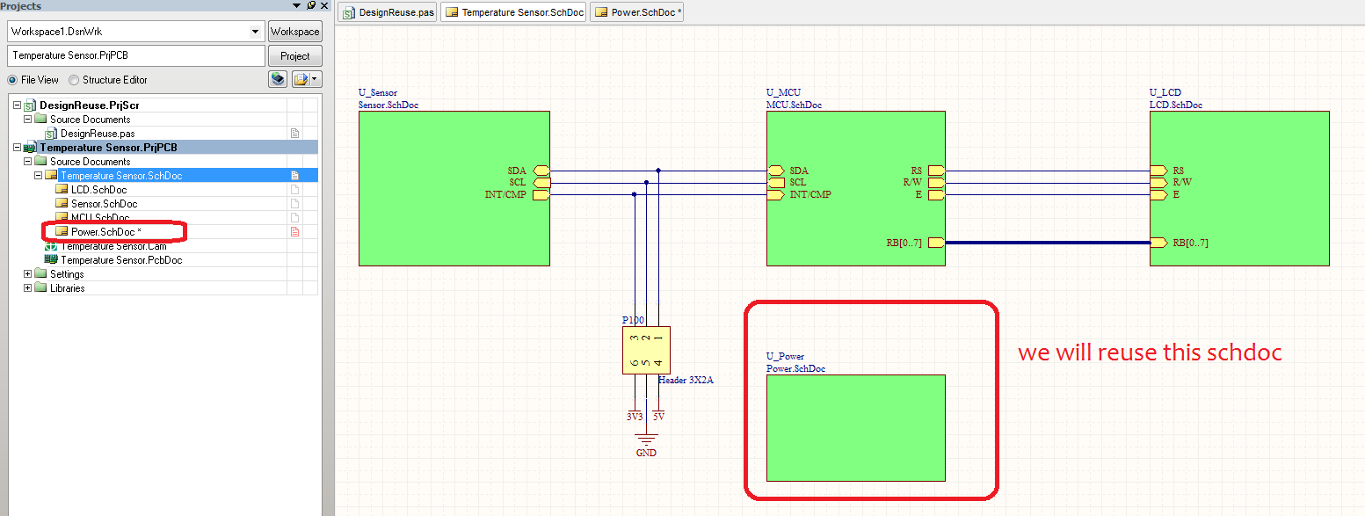

Picture 2 – sheet from which we will save routings.
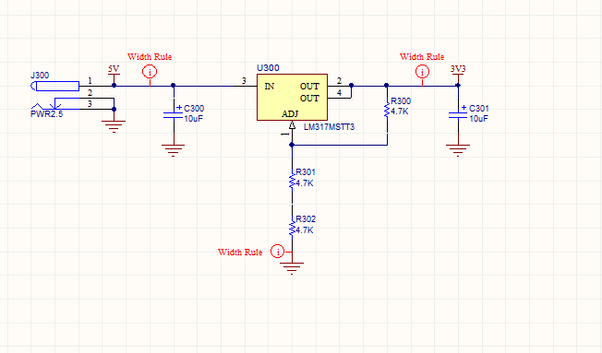

Picture 3 – routings from Power.SchDoc

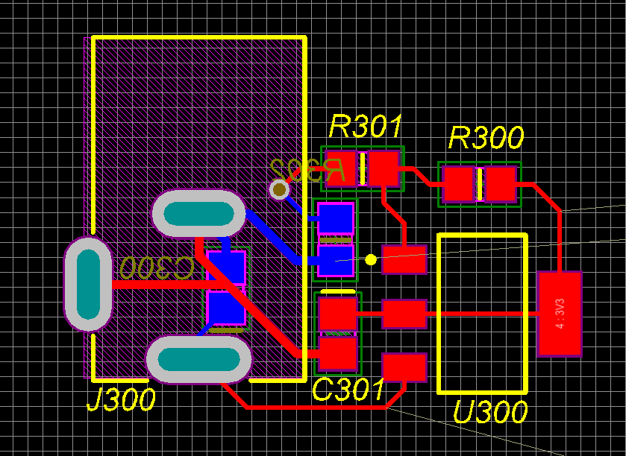

So here are shown the schematic circuit of the design we want to save and PCB routing and placement we want to save.

First thing we will do is create snippet from this selection. So select circuit, right click and do >> Snippets >> Create Snippets From selected objects. Place any snippet name that you want.

Picture 4 – Create snippet, and after you create it, you can see it in "Snippets" panel
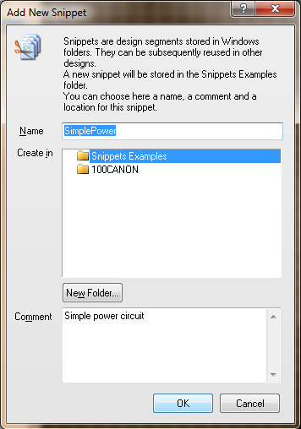
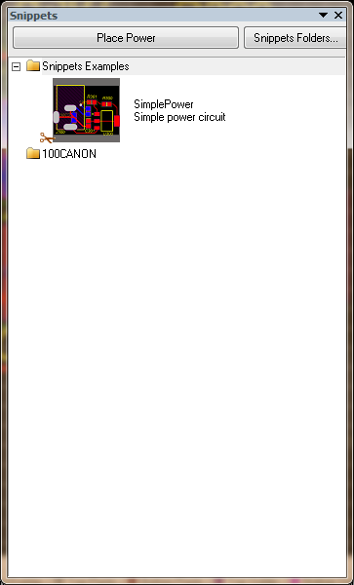

Now we need to add blanket to source sch document, and assign parameter set with that blanket. Blanket needs to include all components from snippet, so if your schematic sheet has components that are not part of the snippet, leave them outside of the blanket.

Picture 5 – source schematic sheet with blanket & parameter set

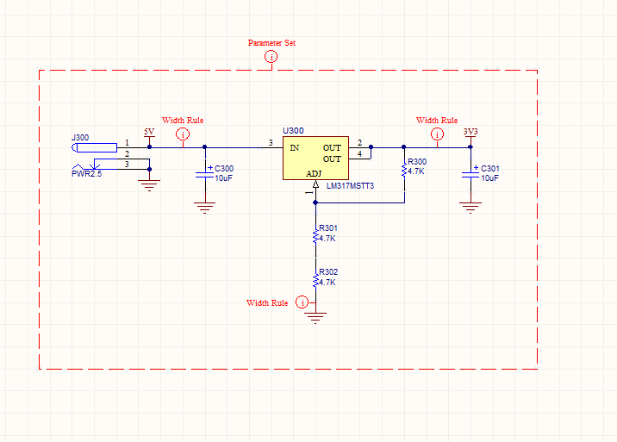

Parameter set has to have parameter whose name is "Snippet", and Value is snippet name. In this case that would be "SimplePower"

Picture 6 – how does parameter look like:

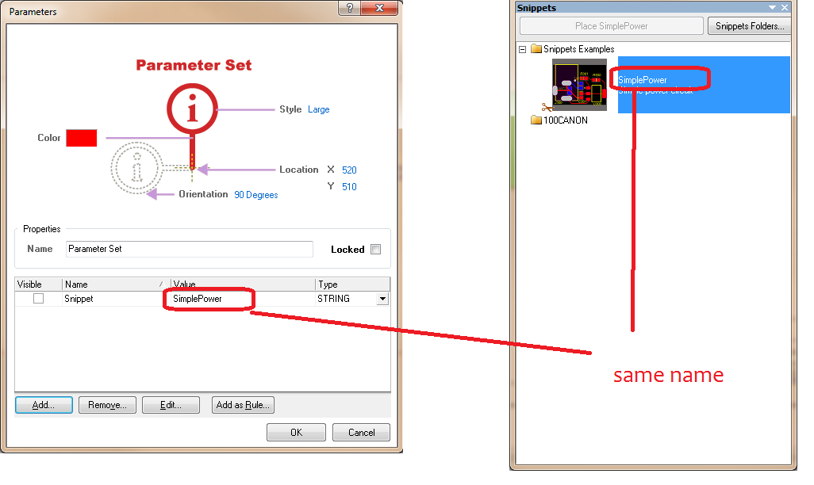
Now save this schematic sheet.
Next what you need to do is create device sheet from this sheet. So select sheet symbol, right click on it >> Refactor >> Convert schematic sheet to device sheet, and you are don with setting data up.

2 – using this in your next design
In your next design you need to:

1 – add device sheet to your project. You can do board level annotation on it, or you can even use REPEAT keyword to repeat this device sheet multiple times (multi-channel design)
2 – Transfer all data to PCB – regular PCB update
3 – with PCB document active, run this script (run DesignReuse procedure).

And that is it :-)

3 – what to look out for
1 – when setting data up, component logical designators from sch and the ones from PCB MUST be the same.
So when you are creating snippet, and adding blanket to sch document, Designators that appear in "Editor" tab, and the ones on PCB must be the same. This is because sctipr matches components using schematic logical designators, and snippet designators. To find regular components it uses uniqueId, so this is not an issue
2 – components that are part of snippet MUST be inside blanket. So if you want to add sch document to device sheet/design reuse, and some of the components are not part of the snippet – simply place them outside of the blanket.
NOTE – script will check where origin of source component is, so if origin of source component is inside blanket it will figure out component is inside blanket.
3 – do not add multiple snippets with the same name (but in separate folders). This version of this script will add first one it finds every time.
4 – Modify script before you use it first time – during scripting I was not able to get snippet folders.
So you will need to manually add them. They need to be added in script around the line 35. This needs to be done only once.
Add all folders in the order they are in your system
Take a look at the picture

Picture 7 – modify script
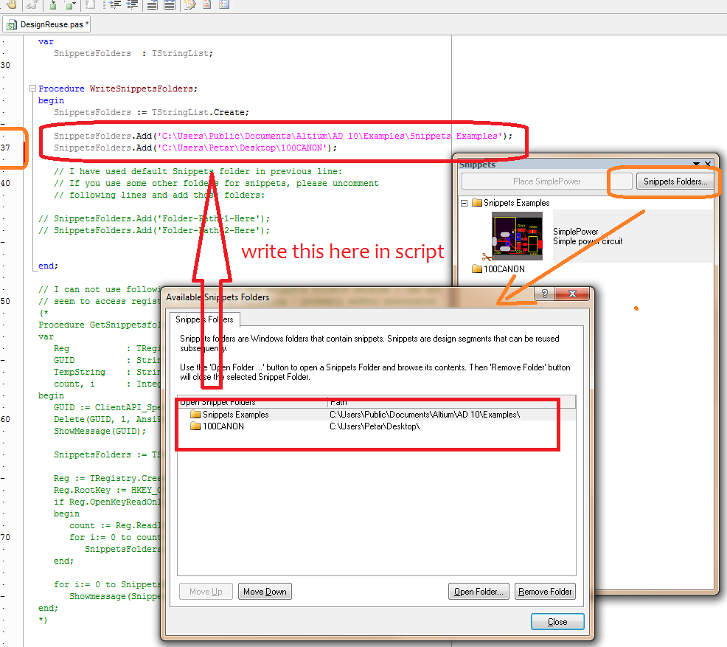

Update – Sheet symbols

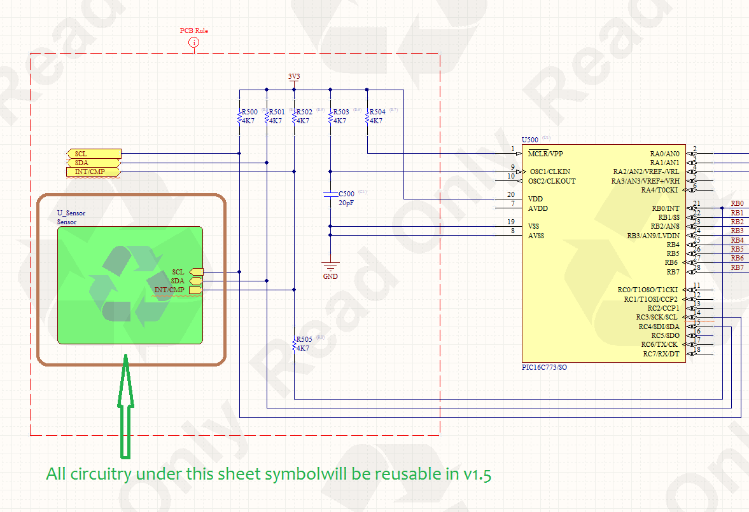
So, in version 1.5 of this script:
- some bugs fixed – I had "close" instead of "exit" in couple of places
- addded the ability to add circuitry under sheet symbols to design reuse
Now, if you have sheet symbols that are also inside blanket, they will also be used in this script. But there is one mayor thing you have to look out for, and in order to explain it to you, I will first explain how this script works

This script first goes through all sch physical documents, and looks for a blanket with assigned parameter set that has "Snippet" parameter. After that it takes all circuitry under.

After that it placers snippet on the PCB, and makes snippet objects (and components) selected (all other objects are deselected). After snippet is placed it needs to connect sch components with snippet components, since snippet components are just some extra components that got placed.

Snippet components are not synchronized with sch in any way, so this script expects snippet designators to be the same as component logical designators. So, script takes sch component and tries to see which of the selected (i.e "snippet") components has the same designator as sch component's logical designator.

If you think this through, this means that
- all parts from snippet must have different designators
- all sch components that are under blanket (or on sch sheets that are represented by the sheet symbol(s) under blanket) must have different logical designators. All of them

In order to help you with this, I have made "TestSnippet" procedure, which will check weather you have duplicated designators in selected components on the PCB.
Before running this procedure:
- go to "Board Options" dialog and make sure you select "Display Logical Designators"
- Select all objects that are part of your snippet
- run this script.

It will report weather some components have duplicate designators. In the future I plan to write one for the sch blanket too.

